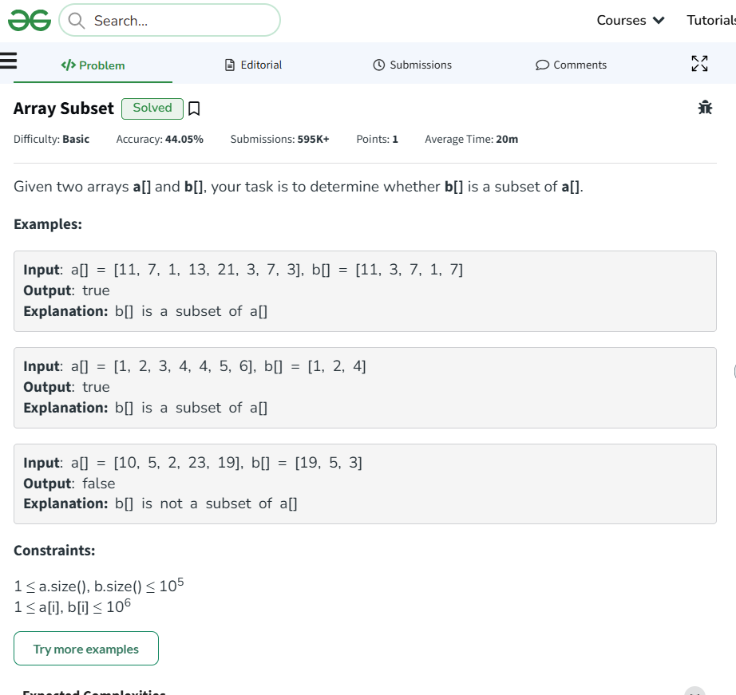
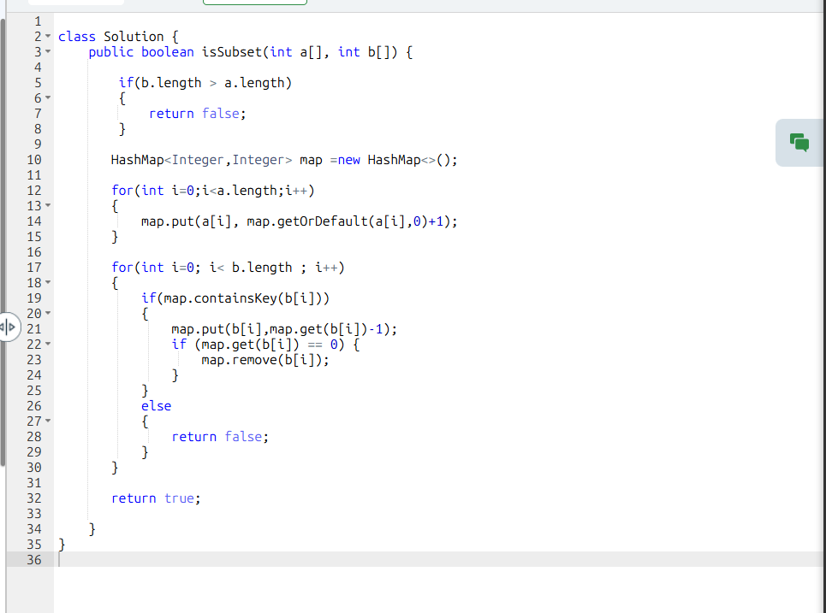

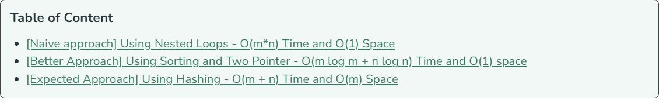

We didn’t used hashset than used hashmap to handle duplicate values in Array B ….

